EADI ISS Conference 2021 Index of Authors: participation in seed panel on migrants struggles for social justice, 5 to 8 July, The Hague.
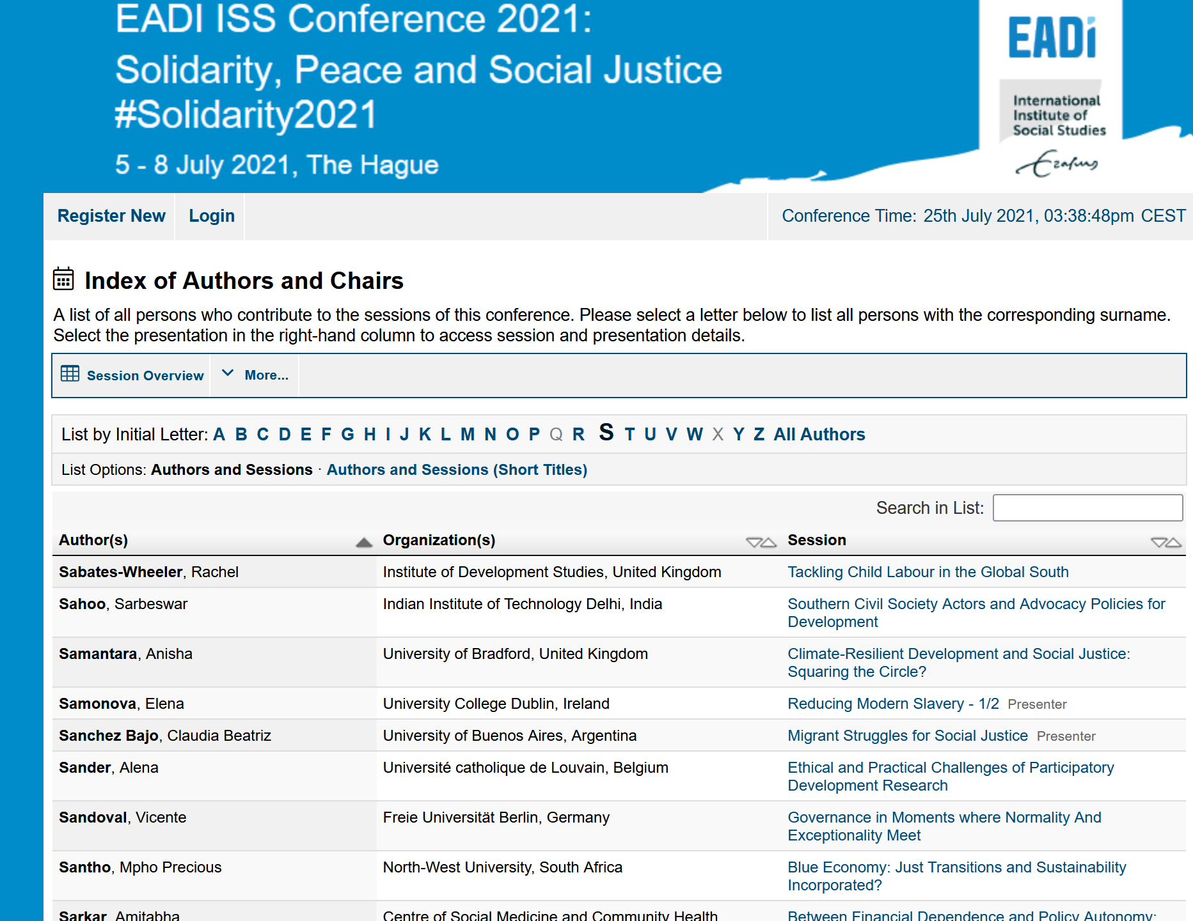
Claudia Sanchez Bajo EADI 2021 conference paper on migrants and reflexive agency

